Characteristics of Effective Learning: Playing and exploring – children investigate and experience things and have a go; Active learning – children concentrate and keep trying if they encounter difficulties and enjoy achievements; Creating and thinking critically – children have and develop their own ideas, make links between ideas, and develop strategies for doing things. In addition, the prime area of learning PSE, CL and PD underpin and are an integral part of all areas of learning.
Physical Development Educational Programme: Physical activity is vital in children’s all-round development, enabling them to pursue happy, healthy and active lives. Gross
and fine motor experiences develop incrementally throughout early childhood, starting with sensory explorations and the development of a child’s strength, co-ordination
and positional awareness through tummy time, crawling and play movement with both objects and adults. By creating games and providing opportunities for play both
indoors and outdoors, adults can support children to develop their core strength, stability, balance, spatial awareness, co-ordination and agility. Gross motor skills provide
the foundation for developing healthy bodies and social and emotional well-being. Fine motor control and precision helps with hand-eye co-ordination, which is later linked
to early literacy. Repeated and varied opportunities to explore and play with small world activities, puzzles, arts and crafts and the practice of using small tools, with
feedback and support from adults, allow children to develop proficiency, control and confidence.
Intent: Through our high-quality physical education curriculum at Kimbolton, we inspire all pupils to succeed and excel in competitive sport and other physical activities. We provide inclusive physical development opportunities for pupils to become confident in a way which supports their health and fitness, self-expression, decision making and social skills. We aim to provide our children with a love for sport and physical activity and it is crucial that our children learn how to keep themselves fit and healthy. Opportunities to compete in sport and other activities build character and help to embed values such as fairness, equality, cooperation and respect. We follow a sequential skills-based curriculum and we strive for our children to develop their gross motor and fine motor skills through a variety of different activities.
Themes | A1 - I wonder what’s marvellous about me  A2 - I wonder what we celebrate |  |  |  | Sp1 – I wonder what’s above and beyond the clouds  Sp2 – I wonder what’s out there |  |  | S1 – I wonder where this journey will take us  S2 - I wonder what happened in the past
Learning Overview | We will focus on developing our fundamental movement skills through the Jungle Journey scheme. If necessary, we will use the Squiggle Whilst you Wiggle scheme to develop our gross motor skills. We will learn to hold a pencil effectively and develop our fine motor skills through our funky finger activities within the provision. We will enjoy some PE dance sessions with a focus on different movements and creating firework dances. |  |  |  | We will learn how to catch and kick a ball in the first part of spring before refining this in spring 2 to include batting, aiming and some team games. We will learn to write recognisable letters as we improve our pencil grips. |  |  | We will enjoy some Gymnastics session for PE, thinking about a range of movements. We will also learn about sportsmanship as we partake in sports day. We will think about the foundations of developing good handwriting and improve our posture as we sit at the table for longer periods of time to prepare for the next stage of our learning. In PE we will explore jumps – tuck, pencil and star and rolls – pencil, teddy bear and egg.
Term | Autumn 1 | Autumn 2 |  |  | Spring 1 |  | Spring 2 | Summer 1 | Summer 2
Gross Motor | To develop skills they need to manage the school day successfully – lining up and queuing and mealtimes  To use core muscle strength to achieve a good posture when sitting on the floor  To use wheeled resources for children to balance, sit or ride on, or pull and push.  To draw lines and circles using gross motor movements. |  |  |  | To revise and refine the fundamental movement skills they have already acquired: skipping, hopping.  To encourage children to be highly active and get out of breath several times every day. |  |  | To use core muscle strength to achieve a good posture when sitting on the table  To run safely on whole foot.  To vary pace depending on distance.  To progress towards a more fluent style of moving, with developing control and grace  To develop the overall body strength, co-ordinaion, balance and agility: spin, rock, tilt, fall, slide and bounce.
PE  Evidence on Tapestry  We revisit knowledge and skills throughout the year | Jungle Journey - fundamental Skills/movement  To revise skills they have already acquired: rolling • crawling • walking • jumping • running • climbing  To stand on one foot. |  | Dance  To experiment with different ways of moving e.g. slithering, shuffling, jumping, sliding.  To combine different movements with ease and fluency. |  | Ball Skills  To develop the ability to control a ball in a range of ways.  To develop the ability to throw accurately at a target.  To use throwing skills in a small sided game.  To be able to use a bat or racket to move and control an object.  To develop the ability catch and bounce a ball.  To develop the ability to kick a ball. | Team Games  To negotiate space successfully in racing and chasing games with others.  To run skilfully, adjusting speed or direction to avoid obstacles. |  | Gymnastics – jumps and rolls  To develop the ability  to jump in a range  of ways from one  space to another.  To control my body  when jumping and  balancing.  To create a sequence  using a jump and a  balance.  To develop the ability  To roll in a range of  ways.  To control my body  when rolling in a  range of ways.  To perform a sequence with confidence and control |  | Gym apparatus and Sports Day (athletics)  To rise to feet without using hands.  To climb confidently and begin to pull themselves up on equipment.  To use a range of large and small apparatus confidently and safely.  To mount stairs, steps or climbing equipment using alternate feet.  To jump off an object and land appropriately.  To travel with confidence and skill around, under and over balancing and climbing equipment.
Key Vocabulary | roll, crawl, walk, jump, run, climb, movement, ease, fluency, muscles, posture, balance |  |  |  | throw, catch, kick, pass, bat, aim, precision, skip, hop, team |  |  | fluent, move, control, grace, strength, co-ordination, balance, agility, spin, rock, tilt, fall, slide, bounce, jump, roll, sequence, pencil roll,
Squiggle Whilst you Wiggle | Up and down movement  Arches, circles and spirals |  |  | Upwards / downwards lines  Spirals and figure of 8 (vertical and horizontal). | Side to side lines  Squares, diagonal lines, triangles. |  | Wavy lines | Zig-zag lines |  |  | Arches
Fine Motor | Jungle Journey/Dough Disco  To develop small motor skills so that they can use a range of tools competently, safely and confidently – scissors, paintbrushes.  To continue developing small motor skills; dressing and undressing dolls, puzzles and playing with small world toys.  To draw and make-marks and symbols using writing implements.  To show preference for dominant hand.  To hold pencil/paint brush beyond whole hand grasp.  To develop muscle tone to put pencil pressure on paper.  To draw, write or copy letter of name  To teach and model correct letter formation.  To cut a straight line with the scissors |  |  |  | Pen Disco  To refine small motor skills; threading, pouring, stirring, using spray bottles, planting and caring for plants, playing with small world toys.  To practise holding a pencil with improved grip.  To write and copy letters and begin forming letter correctly.  To engage within daily name/CVC writing activities..  To begin to form letters correctly.  To handle tools, objects, construction and malleable materials with increasing control.  To cut a simple curved line with the scissors  To hold pencil effectively with comfortable grip  To draw a cross.  To draw pictures that are recognisable  To use a range of small tools, including scissors, paint brushes and cutlery. |  |  | To develop the foundations of a handwriting style which is fast, accurate and efficient.  To hold a pencil effectively in preparation for fluid writing using the tripod grip in almost all cases/  To use one hand consistently for fine motor tasks.  To form letters correctly  To copy a square  To begin to draw diagonal lines, like in a triangle  To start to colour inside the lines of a picture  To build things with smaller linking blocks, such as Lego.  To begin to show accuracy and care when drawing.
Our Curriculum Goal | To become an Amazing Athlete who can show strength, balance and co-ordination when playing, move confidently and safely in a variety of different ways, use a range of equipment.  To become a Talented Tool User who can hold a pencil effectively, use a range of tools (for example scissors, cutlery, paintbrushes, tweezers, hammer, screwdrivers) safely and with confidence.
ELG  (End of the year only) | Gross Motor Skills  - Negotiate space and obstacles safely, with consideration for themselves and others;  - Demonstrate strength, balance and coordination when playing;  - Move energetically, such as running, jumping, dancing, hopping, skipping and climbing.  Fine Motor Skills  - Hold a pencil effectively in preparation for fluent writing – using the tripod grip in almost all cases;  - Use a range of small tools, including scissors, paint brushes and cutlery;  - Begin to show accuracy and care when drawing.
During KS1, children will learn | During KS1, children will learn  - Pupils should develop fundamental movement skills, become increasingly competent and confident and access a broad range of opportunities to extend their agility, balance and coordination, individually and with others.  - They should be able to engage in competitive (both against self and against others) and co-operative physical activities, in a range of increasingly challenging situations.  Pupils should be taught to:  - master basic movements including running, jumping, throwing and catching, as well as developing balance, agility and co-ordination, and begin to apply these in a range of activities  - participate in team games, developing simple tactics for attacking and defending  - Perform dances using simple movement patterns.  Swimming & Water Safety  All schools must provide swimming instruction either in KS1 or KS2.  - Swim competently, confidently and proficiently over a distance of at least 25 metres.  - Use a range of strokes effectively [for example, front crawl, backstroke and breaststroke].  - Perform safe self-rescue in different water-based situations.

Our PE journey through the year
To use wheeled resources for children to balance, sit or ride on, or pull and push.
To use the trim trail to develop gross motor skills.
To develop small motor skills so that they can use a range of tools competently, safely and confidently – scissors, paintbrushes.

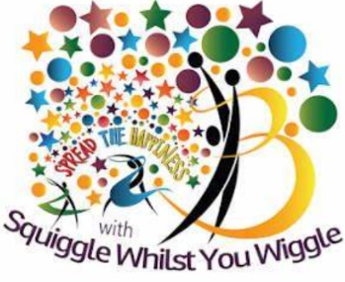
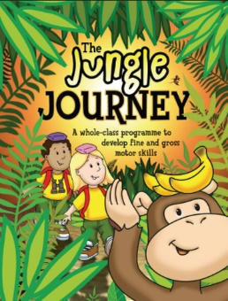

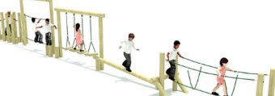
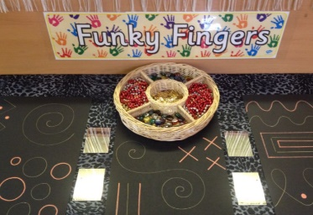
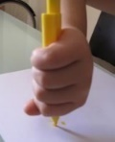
To draw and make-marks and symbols using writing implements
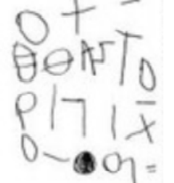
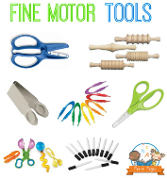
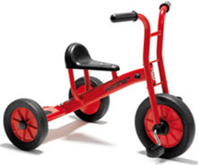
To combine different movements with ease and fluency.
To create a firework dance

To develop gross and fine motor skills through various activities
To revise and refine the fundamental movement skills

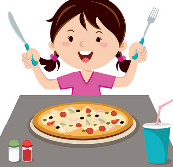
To practise holding a pencil with improved grip.
To write and copy letters.
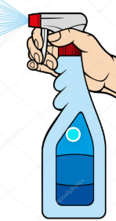
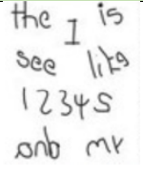

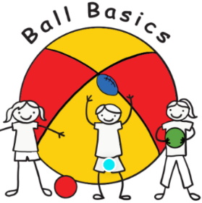
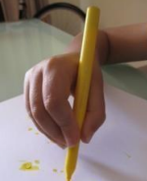
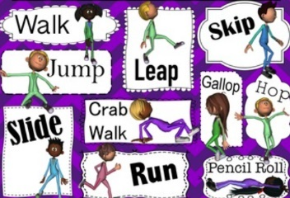
To develop skills they need to manage the school day successfully – lining up and queuing and mealtimes.

To develop ball skills including throwing, and catching

To refine small motor skills; threading, pouring, stirring, using spray bottles, planting and caring for plants, playing with small world toys.
To hold a pencil effectively and show increased control.
To revise and refine the fundamental movement skills they have already acquired: skipping, hopping.

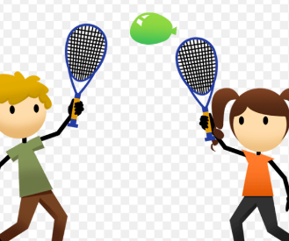
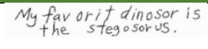
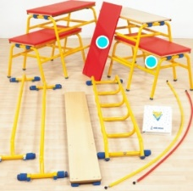

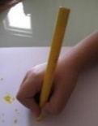
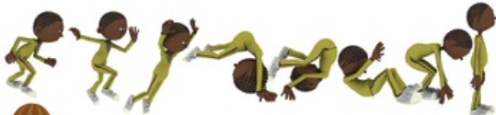

To develop and refine a range of ball skills including kicking, passing, batting, and aiming.
To develop confidence, competence, precision and accuracy when engaging in activities that involve a ball.

To develop good sportsman ship when partaking in Sports Day.
To develop the overall body strength, co-ordination, balance and agility: spin, rock, tilt, fall, slide and bounce.
To explore jumps and rolls.

To use a range of large and small apparatus confidently and safely

