Characteristics of Effective Learning: Playing and exploring – children investigate and experience things and have a go; Active learning – children concentrate and keep trying if they encounter difficulties and enjoy achievements; Creating and thinking critically – children have and develop their own ideas, make links between ideas, and develop strategies for doing things. In addition, the prime area of learning PSE, CL and PD underpin and are an integral part of all areas of learning.
Understanding the World Educational Programme: Understanding the world involves guiding children to make sense of their physical world and their community. The frequency and range of children’s personal
experiences increases their knowledge and sense of the world around them – from visiting parks, libraries and museums to meeting important members of society, such as police officers,
nurses and firefighters. In addition, listening to a broad selection of stories, non-fiction, rhymes and poems will foster their understanding of our culturally, socially, technologically and
ecologically diverse world. As well as building important knowledge, this extends their familiarity with words that support understanding across domains. Enriching and widening children’s
vocabulary will support later reading comprehension.
Intent: Through our history curriculum we want our children to understand and respect the past whilst fostering their curiosity. We will do this in a relevant context to equip them with
historical skills and the spirit of enquiry to prepare for future learning. Our curriculum contains a well thought out, relevant balance of local, national and global history.
Themes | A1 - I wonder what’s marvellous about me  A2 - I wonder what we celebrate |  |  | Sp1 – I wonder what’s above and beyond the clouds  Sp2 – I wonder what’s out there |  | S1 – I wonder where this journey will take us  S2 - I wonder what happened in the past
Learning Overview | We will talk to our grandparents and parents and think about how we’ve developed from a baby to a child. We will look at the job/roles of members of our families. We will share our weekend news and use the past tense correctly. We will remember the story of Guy Fawkes and say why this was an important event. We will also reflect on Remembrance Sunday and begin to understand why some people do this. |  |  | We will look at farm machinery and think about how they are different to now. We will use a timeline to put things in order. We will think about how the passage of time changes the world around us. We will look at an historical figure and event from the past. We will recall some traditional tales and understand they have been told many times before, and in different ways. |  | We will learn about things from the past such as dinosaurs and pirates and understand they were alive in the past. We will look at 2 characters from the past. We will think about how the passage of time changes us all. We will refer to what we did in the past using the correct tense. We will think about what we would like to be when we grow up.
Term | Autumn 1 |  | Autumn 2 | Spring 1 | Spring 2 | Summer 1 | Summer 2
History  Evidence in Floor Book  We revisit knowledge and skills throughout the year | To use past tense when talking about their personal histories.  To understand that time passes in sequential order.  To comment on images of familiar situations in the past (Summer Scrapbook) | To talk about members of their family and the community and their roles (parents, fire people, vicars)  To understand that events/celebrations take place at specific points of the year.  To know about some familiar situations in the past (Christmas) |  | To know that the passage of time changes the world around us.  To know that we need to change what we do/wear in response to the passage of time.  To know about influential figures and discuss historical events that have happened in the past – Neil Armstrong, Tim Peake, Mae Jamison (astronauts) | To compare transport/machinery and talk about how these have changed from the past. | To explore the life of Mary Read (pirate)  To know that the passage of time changes us all. | To know about influential figures and discuss historical events that have happened in the past – Mary Anning (palaeontologist)  To know how I have changed as I look back over the school year.  To talk about their future aspirations.
History Sticky Knowledge  Knowledge children need to know by the end of every half-term. | I know about my own life-story  I know how I have changed from a baby  I know that as I get older I can do different things.  I know words relating to time today/yesterday/  tomorrow |  | I know about some familiar situations in the past  I know some celebrations / festivals and can say why they are celebrated (Christmas, Easter, Bonfire Night, Diwali, Chinese New Year). | I know some facts about people from the past – Guy Fawkes, God, Neil Armstrong, Tim Peake. | I know which objects are from the past and which are modern.  I know words relating to time – old/new | I know comparative language – same/different  I know that some stories have been around for a long time and that some are new. | I know how I have changed as I look back over this year at school
Key vocabulary/  phrases | remember, routine, past, history, then, now, time, yesterday, today, tomorrow, sequence, growing, growth, timeline, chronology, life cycle | remembrance, celebration |  | before I was born, a long time ago, in the past | change, past, antique, old, new, vintage | comparison, similarity, difference | present, prehistoric, future
Our Curriculum Goal | To become an Exceptional Explorer who can show curiosity about the world around them, understand how to read and draw a simple map, understand some differences between times and places.
ELG  (End of the year only) | - Talk about the lives of the people around them and their roles in society.  - Know some similarities and differences between things in the past and now, drawing on their experiences and what has been read in class.  - Understand the past through settings, characters and events encountered in books read in class and storytelling.
During KS1, children will learn | - Changes within living memory. Where appropriate, these should be used to reveal aspects of change in national life  - Events beyond living memory that are significant nationally or globally [for example, the Great Fire of London, the first aeroplane flight or events commemorated through festivals or anniversaries]  - The lives of significant individuals in the past who have contributed to national and international achievements. Some should be used to compare aspects of life in different periods [for example, Elizabeth I and Queen Victoria, Christopher Columbus and Neil Armstrong, William Caxton and Tim Berners-Lee, Pieter Bruegel the Elder and LS Lowry, Rosa Parks and Emily Davison, Mary Seacole and/or Florence Nightingale and Edith Cavell]  - Significant historical events, people and places in their own locality.

EYFS history knowledge and skills linking to year 1
Changes within living memory  Begin to make sense of their own life-story and family’s history.  Understand the ways I have changed.  Talk about the changes that have happened within my family lifetime e.g. talking to grandparents about holiday etc.  Talk about the lives of the people around them and their roles in society.  Talk about how they have changed as they look back over this year at school | Events beyond living memory  Know about influential figures and discuss historical events that have happened in the past.  - Moon landing/space  - Dinosaurs | The lives of significant individuals in the past  Compare and contrast characters from stories, including figures from the past  Understand the past through settings, characters and events encountered in books read in class and storytelling.  - Neil Armstrong (US astronaut)  - Tim Peak (UK astronaut)  - Mae Jamison (first black women to travel to space)  - Mary Anning (palaeontologist)

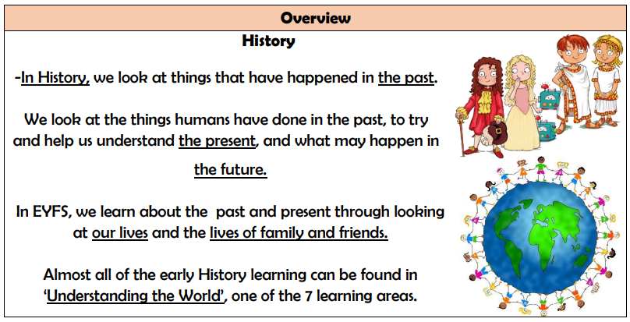
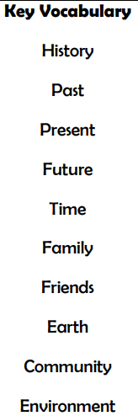
Our history journey through the year
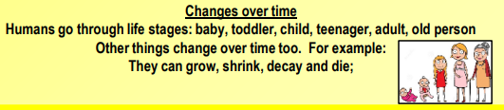

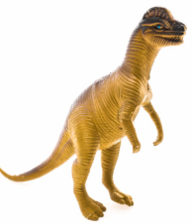
To know they have grown from a baby to a child
To use past tense when talking about their personal histories.
To understand that time passes in sequential order
To know how I have changed as I look back over the school year.

To know dinosaurs lived a long time ago.
Significant Events:
The Gunpowder Plot 5th November 1605
Remembrance Day 11th November 1918
The Moon Landing 20th July 1969

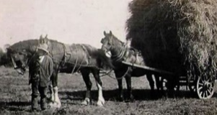
To understand that events/celebrations take place at specific points of the year.

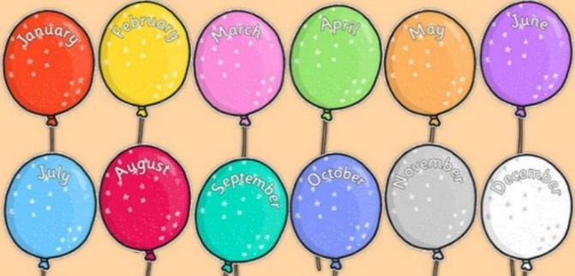
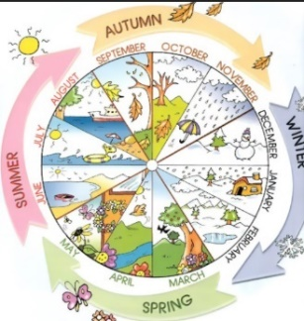
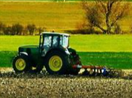
Significant people
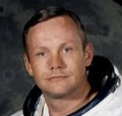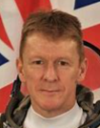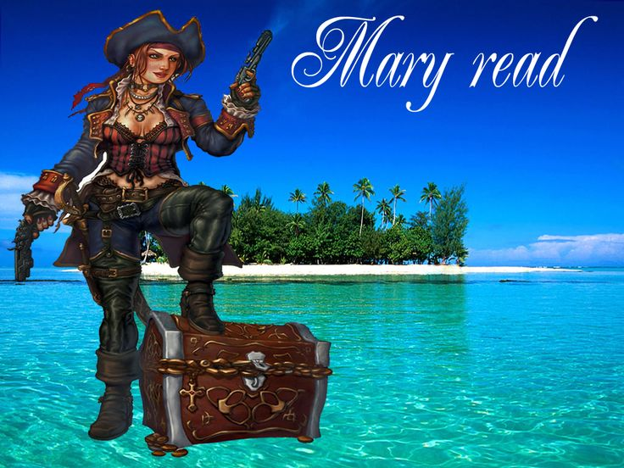
Neil Armstrong Tim Peake Mary Read

To understand a horse and cart was used to farm in the past but now we use tractors.

To know harvest is a time to say thank you!
To know that we need to change what we do/wear in response to the passage of time.

To understand how things have changed
To know about influential figures and discuss historical events that have happened in the past.

To understands birthdays are celebrated to remember the day they were born.
To know about some familiar situations in the past

