What an artist looks like in the EYFS
Characteristics of Effective Learning: Playing and exploring – children investigate and experience things and have a go; Active learning – children concentrate and keep trying if they encounter difficulties and enjoy achievements; Creating and thinking critically – children have and develop their own ideas, make links between ideas, and develop strategies for doing things. In addition, the prime area of learning PSE, CL and PD underpin and are an integral part of all areas of learning.
Expressive Arts & Design Educational Programme: The development of children’s artistic and cultural awareness supports their imagination and creativity. It is important that children have regular opportunities to
engage with the arts, enabling them to explore and play with a wide range of media and materials. The quality and variety of what children see, hear and participate in is crucial for developing
their understanding, self-expression, vocabulary and ability to communicate through the arts. The frequency, repetition and depth of their experiences are fundamental to their progress in
interpreting and appreciating what they hear, respond to and observe.
Intent: At Kimbolton we inspire our children to unleash their inner artist. We develop their skills and proficiency using a range of media. The children will develop an appreciation of internationally renowned artists. They will evaluate and analyse others work and acquire a critical understanding of a range of artistic techniques. They will have hands on experiences that will enhance their skills and build their creativity.
Themes | A1 - I wonder what’s marvellous about me  A2 - I wonder what we celebrate |  | Sp1 – I wonder what’s above and beyond the clouds  Sp2 – I wonder what’s out there |  |  | S1 – I wonder where this journey will take us  S2 - I wonder what happened in the past
Learning Overview | We will use thick and thin paintbrushes to create different lines as we create our self-portraits. We will mix paints and explore which colours we can make as we create firework pictures. We will also explore the splatter art technique in our outdoor environment. We will shape and mould clay to make a diva lamp to celebrate Diwali. We will create natural/transient art inspired by artist Andy Goldsworthy. |  | We will use colour appropriately and make careful choices when colouring and drawing plants and animals. We will select which paintbrush we need to create different lines. We will create a space drip painting inspired by Jackson Pollock. We will recreate patterns using vegetables and include this in our artwork. |  |  | We will accurately mix paints to create a new colour and think about shades and tints. We will create a dotty art African animal and seaside landscape scene using watercolours.
Term | Autumn 1 | Autumn 2 | Spring 1 | Spring 2 |  | Summer 1 | Summer 2
Art  Evidence in Floor Book  We revisit knowledge and skills throughout the year | To use a variety of drawing tools and techniques – chalk, pencil, pastels, charcoal  To draw with some detail, such as representing a face with a circle and including details (self-portraits).  To explore transient art (art without glue) using a variety of resources both natural and man -made, inspired by Andy Goldsworthy | To explore colours and how to mix them  To know that primary colours make secondary colours when mixed together  To use the splatter art technique (firework picture)  To know how to sculpt, shape and mould clay (Diva Lamp)  To know about different forms. | To explore textures and colour by creating a collage (Chinese dragon)  To explore the drip technique inspired by Jackson Pollock (space painting) | To develop knowledge of colour mixing  To explore printing with wooden blocks, fruit and vegetables  To use lines when doing observational drawing of a plant or animal  To know how to use a variety of drawing tools and techniques – sketch (pencil, inks, and paint) |  | To return to and build on previous learning, refining ideas and developing their ability to represent them.  To explore the dotty art technique (African animal painting using cotton bud) | To add white or black paint to alter the shade or tint when using watercolours (seaside scene)  To use a thin paintbrush to add detail.  To know how to sculpt, shape and mould salt-dough (fossils)
Art Sticky Skills & Knowledge  Skills and Knowledge children need to know by the end of every half-term. | I can use a variety of drawing tools to create marks. | I know that when I mix two colours it makes a different colour.  I know that materials can be joined / mixed to create interesting effects. | I know that artists create works of art.  I know how to use a paint brush and palette | I know how to match the colours I see to what I want to represent. |  | I know a variety of artist techniques that I can use in my own artwork.  . transient  . splatter  . drip  . dotty | I can talk about what I see in a picture or piece of art.  I know how to use paint tools with care and precision.
Key vocabulary | express, feelings, draw, technique, pastels, detail, transient, natural art, artist | colour, mix, primary, secondary, splatter, sculpt, shape, mould, clay, form | collage, texture, drip, palette |  | observation, draw, sketch, pencil, ink, paint, line,  print, block, pattern | refine, represent, shade, tint, detail, thin, care, precision
Our Curriculum Goal | To become a Dynamic Designer who can choose and safely use the resources they need to make their creations, talk about what they have made and how they have made it.
ELG  (End of the year only) | Creating with Materials  - Safely use and explore a variety of materials, tools and techniques, experimenting with colour, design, texture, form and function.  - Share their creations, explaining the process they have used.  - Make use of props and materials when role playing characters in narratives and stories.
During KS1, children will learn | During KS1, children will learn  - to use a range of materials creatively to design and make products  - to use drawing, painting and sculpture to develop and share their ideas, experiences and imagination  - to develop a wide range of art and design techniques in using colour, pattern, texture, line, shape, form and space  - about the work of a range of artists, craft makers and designers, describing the differences and similarities between different practices and disciplines, and making links to their own work.

EYFS art knowledge and skills linking to year 1
Mark-making and drawing (pencil, charcoal, inks, chalk, pastels, ICT software) | Colour (painting, ink, pencils, crayon, pastels) | Texture (clay, sand, stone, natural materials) | Form (3D work, clay, dough, boxes, paper sculpture) | Printing (found materials, fruit/veg, wood blocks, press print, lino, string) | Suggested artists  Techniques
Begin to use a variety of drawing tools and techniques  Draw with some detail, such as representing a face with a circle and including details.  Use lines when doing observational drawings | Explore colours and how to mix them  Know that primary colours make secondary colours when mixed together  Explore tints and shades and when these should be used. | Explore and experiment with different textures  Safely use and explore a variety of materials.  Explore transient art (art without glue) using a variety of resources both natural and man -made, inspired by Andy Goldsworthy  Explore textures by creating a collage | Handling, feeling, enjoying and manipulating materials  Shape and model  Experiment with different forms. | Rubbings  Print with variety of objects and colours  Explore printing with wooden blocks, fruit and vegetables | Andy Goldsworthy – natural art  Kandinsky – concentric circles  Jackson Pollock – drip  Splatter

Our art journey through the year

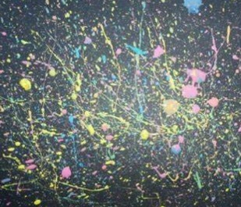
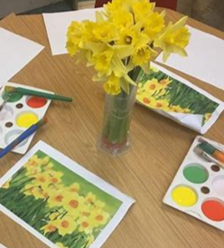
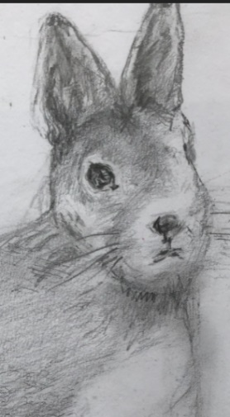
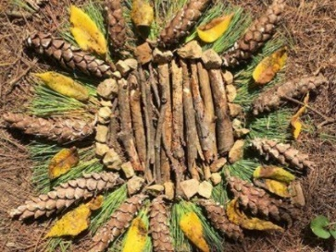
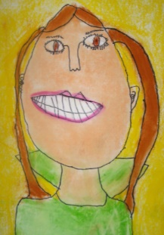
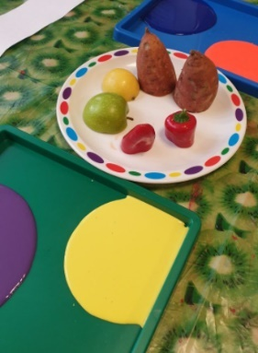

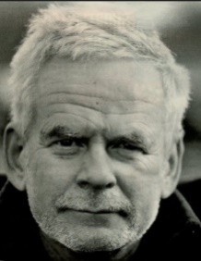
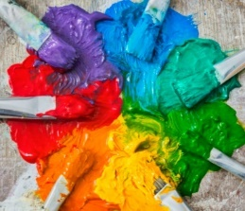
To use a variety of drawing tools and techniques – chalk, pencil, pastels, charcoal
To draw with some detail, such as representing a face with a circle and including details.

To know how to use a variety of drawing tools and techniques – sketch, pencil, inks, and paint
To use lines when doing observational drawing of a plant or animal

To explore printing with wooden blocks, fruit and vegetables

To explore colours and how to mix them
To know that primary colours make secondary colours
To use the splatter art technique

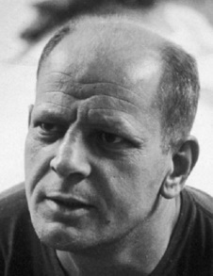
To explore transient art using a variety of resources both natural and man -made inspired by
Andy Goldsworthy
Andy Goldsworthy
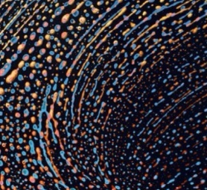
To explore the drip technique inspired by
Jackson Pollack

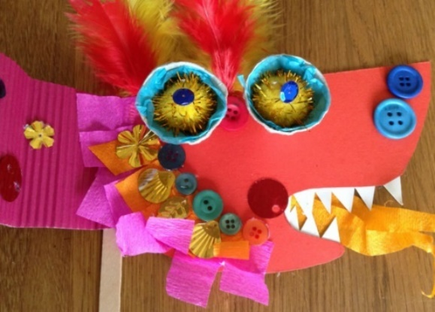
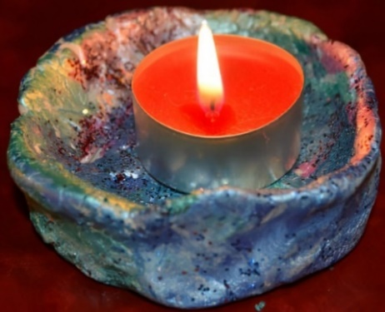

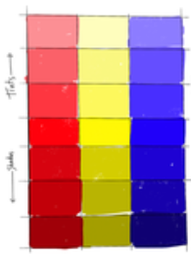
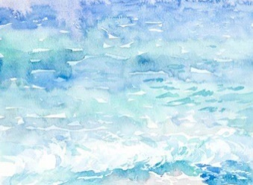

To explore textures and colour by creating a collage Chinese dragon

To add white or black paint to alter the shade or tint when using watercolours
To use a thin paintbrush to add detail.

To know how to sculpt, shape and mould clay
To know about different forms.

