Characteristics of Effective Learning: Playing and exploring – children investigate and experience things and have a go; Active learning – children concentrate and keep trying if they encounter difficulties and enjoy achievements; Creating and thinking critically – children have and develop their own ideas, make links between ideas, and develop strategies for doing things. In addition, the prime area of learning PSE, CL and PD underpin and are an integral part of all areas of learning
Understanding the World Educational Programme: Understanding the world involves guiding children to make sense of their physical world and their community. The frequency and range of
children’s personal experiences increases their knowledge and sense of the world around them – from visiting parks, libraries and museums to meeting important members of society, such as
police officers, nurses and firefighters. In addition, listening to a broad selection of stories, non-fiction, rhymes and poems will foster their understanding of our culturally, socially,
technologically and ecologically diverse world. As well as building important knowledge, this extends their familiarity with words that support understanding across domains. Enriching and
widening children’s vocabulary will support later reading comprehension.
Intent: Science helps everyone to understand the world they live in. It is constantly changing our lives and it relates to things we see and do on a daily basis. At Kimbolton we offer the
children a science curriculum that evokes curiosity, excitement and understanding about the world around them. We encourage our children to ask questions and then experiment to find out
the answers to their questions. We understand the need for practical, hands on experiences, allowing the children time to explore and investigate. We want to teach our children to love
discovering new things, and think of themselves as scientists as they begin to understand the natural world around them.
Themes | A1 - I wonder what’s marvellous about me  A2 - I wonder what we celebrate |  | Sp1 – I wonder what’s above and beyond the clouds  Sp2 – I wonder what’s out there |  | S1 – I wonder where this journey will take us  S2 - I wonder what happened in the past
Learning Overview | We will explore the natural world, commenting on seasonal changes and the weather. We will look what happens to trees and the weather during autumn and winter. We will use our senses during our exploration of the outdoor environment. |  | We will look at the change of seasons and what happens to some plants and animals during spring. We will learn about space and be able to name some of the planets. We will look at the schools grounds and local environment and see which animals and plants we can draw, observe and name. We will look at plants and animals from hot and cold countries. We will also learn about life cycles of humans and some animals. We will learn about caterpillars, bees and other insects. We will look at changes to ice and melting chocolate. |  | We will recognise some similarities and differences in how our environment looks now compared to the past year. We will talk about dinosaurs being herbivores, carnivores and omnivores. We will look at what happens to the weather/climate during summer. We will explore materials and identify what materials would make the best boat. We will think about materials being waterproof or not waterproof and test our theories as well as identifying objects that float/sink and explain their reasons.
Term | Autumn 1 | Autumn 2 | Spring 1 | Spring 2 | Summer 1 | Summer 2
Science  Evidence in Floor Book  We revisit knowledge and skills throughout the year | To explore the natural world around them.  To describe what they see, hear and feel whilst outside. | To understand what changes happen in Autumn and winter and note some differences. | To know all 5 senses and explain what they are.  To explore and talk about different forces e.g. gravity, push and pull  To know that things can melt and freeze and understands how to make these changes occur. | To understand what changes happen in spring, discussing when and how things grow.  To observe and draw pictures of animals and plants.  To name 3 animals and their young  To explain the lifecycle of a plant and one animal.  To know how to care for growing plants  To know about healthy foods that grow naturally.  To know that things can melt and understands how to make these changes occur. | To talk about similarities and differences between materials and changes they notice.  To identify the best material that is waterproof and best for its purpose.  To give an explanation as to why something floats or sinks.  To know why it is important to recycle and how this helps our planet earth. | To name and order the seasons.  To explore the lives and diets of dinosaurs.  To know earth is the planet we live on  To understand how human activity can have a negative impact on the environment and what they can do to look after the natural world.
Science Sticky Knowledge  Knowledge children need to know by the end of every half-term | I know I need to respect and care for the natural environment and all living things. | I know what the weather is like in Autumn. | I know all 5 senses and can describe the world through using my senses.  I know that ice melts when it gets hot.  I know that water turns into ice when it freezes. | I know that a plant needs light, soil and water to grow.  I know that plants die if they don’t have enough water.  I know some foods that are healthy and not healthy (PSHE)  I know the name of some insects.  I know that a caterpillar becomes a butterfly | I know that the weather is different in different parts of the world.  I know that some materials float and some sink.  I know that some materials are better suited to jobs than others.  I know some similarities and differences in relation to materials  I know that food grows on trees and some comes from plants on and under the ground. | I know the names of the four seasons.  I know some dinosaurs used to eat other dinosaurs and others used to eat plants.  I know the main changes that happen in Autumn, Winter, Spring and Summer.  I know that my actions affect the world.
Key vocabulary | senses, natural, changes | season, autumn, winter, rain, wind, cloudy | hear, see, feel, sense, freeze, ice, force, gravity, melt, pressure, air, thrust | habitat, plant, grow, change, spring, survive, observe, animal, lifecycle, healthy, melt | materials, waterproof, float, sink | autumn, winter, spring, summer, hot, sunny, care, environment
Our Curriculum Goal | To become an Exceptional Explorer who can show curiosity about the world around them, understand how to read and draw a simple map, understand some differences between times and places.
ELG  (End of the year only) | - Explore the natural world around them, making observations and drawing pictures of animals and plants.  - Know some similarities and differences between the natural world around them and contrasting environments, drawing on their experiences and what has been read in class.  - Understand some important processes and changes in the natural world around them, including the seasons and changing states of matter
During KS1, children will learn | PLANTS  - Identify and name a variety of common wild and garden plants, including deciduous and evergreen trees  - Identify and describe the basic structure of a variety of common flowering plants, including trees.  ANIMALS (INC HUMANS)  - Identify and name a variety of common animals including fish, amphibians, reptiles, birds and mammals  - identify and name a variety of common animals that are carnivores, herbivores and omnivores  - Describe and compare the structure of a variety of common animals (fish, amphibians, reptiles, birds and mammals, including pets)  - Identify, name, draw and label the basic parts of the human body and say which part of the body is associated with each sense.  EVERYDAY MATRERIALS  - Distinguish between an object and the material from which it is made.  - Identify and name a variety of everyday materials, including wood, plastic, glass, metal, water, and rock.  - Describe the simple physical properties of a variety of everyday materials.  Compare and group together a variety of everyday materials on the basis of their simple physical properties.

EYFS science knowledge and skills linking to year 1
Working scientifically | Plants | Animals (Including humans) | Everyday materials
Comments and asks questions about aspects of their familiar world such as the natural world, making observations and drawing pictures of animals and plants.  Talks about why things happen and how things work  Looks closely at similarities, differences, patterns and change  Understand some important processes and changes in the natural world around them, including the seasons and changing states of matter  Explore and talk about different forces I can feel – gravity, push and pull toys | know that a plant needs light, soil and water to grow.  Know that plants die if they don’t have enough water.  Know that some food grows on trees and some comes from plants on and under the ground. | I know the name of some insects.  I know that a caterpillar becomes a butterfly  Identify which dinosaurs are meat or plant eaters | Know that some materials float and some sink.  Know that some materials are more suited to jobs than others.  Know some similarities and differences in relation to materials
Our science journey through the year
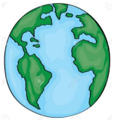
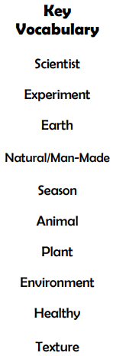
To describe what they see, hear and feel whilst outside.
To name the 5 senses

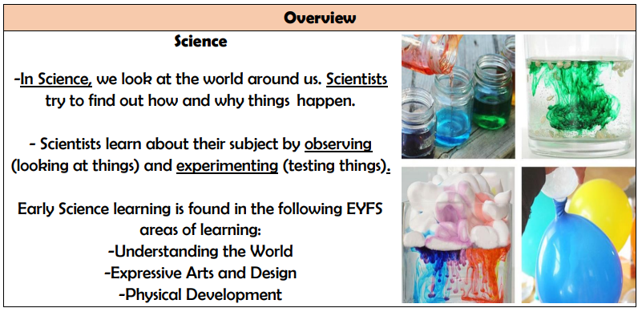

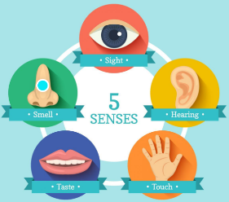
To know earth is the planet we live on.
To understand how human activity can have a negative impact on the environment and what they can do to look after the natural world.

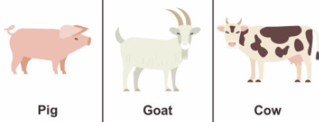
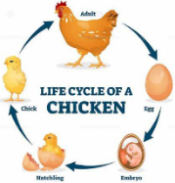

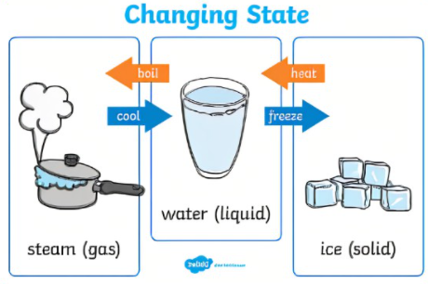
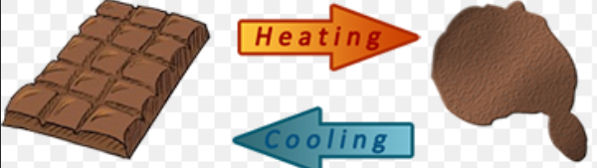
To explain the lifecycle of a plant and one animal.

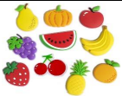
To name 3 animals and their young.

To understand what changes happen in Autumn and winter and note some differences.
To understand what changes happen in spring, discussing when and how things grow.
To name and order the seasons.

To know about healthy foods that grow naturally.
To know that things can freeze and melt and understands how to make these changes occur.

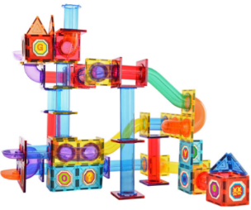
To know how to care for a growing plant
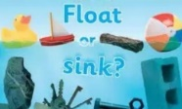
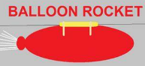
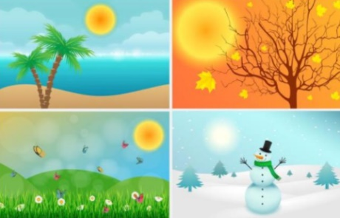
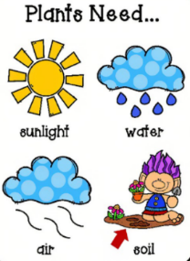
To talk about similarities and differences between materials and changes they notice.
To identify the best material that is waterproof and best for its purpose.
To give an explanation as to why something floats or sinks.

To explore and talk about different forces e.g. gravity, push and pull

