Characteristics of Effective Learning: Playing and exploring – children investigate and experience things and have a go; Active learning – children concentrate and keep trying if they encounter difficulties and enjoy achievements; Creating and thinking critically – children have and develop their own ideas, make links between ideas, and develop strategies for doing things. In addition, the prime area of learning PSE, CL and PD underpin and are an integral part of all areas of learning
The most relevant statements for computing are taken from the following areas of learning:
• Personal, Social and Emotional Development
• Physical Development
• Understanding the World
• Expressive Arts and Design
Intent: At Kimbolton St James, we develop the foundational skills of computing. We hope to develop safe, responsible and competent learners who can navigate and investigate using technology.
For children to develop the knowledge and skills they need to keep themselves safe online and to prepare children for the pivotal role technology will play in their lives, both as children and
adults.
Themes | A1 - I wonder what’s marvellous about me  A2 - I wonder what we celebrate | Sp1 – I wonder what’s above and beyond the clouds  Sp2 – I wonder what’s out there | S1 – I wonder where this journey will take us  S2 - I wonder what happened in the past
Learning Overview | We will begin exploring a range of technological equipment and think about operating equipment in the provision e.g. CD player and playing on the interactive white board. | We will discuss the importance of internet safety and what we should do if we face an issue. We will create posters to remind nursery of the rules e.g. Click x on pop ups and asking grown ups for help. We will play games to enhance others areas of learning, such as art and mathematics. | We will think about what technology we use at home and why it is useful and important. We will explore directions and basic coding.
Computing  Evidence on Tapestry  We revisit knowledge and skills throughout the year | - To show resilience and perseverance in the face of a challenge.  - To know and talk about the different factors that support their overall health and wellbeing: -sensible amounts of ‘screen time’.  - To develop their small motor skills so that they can use a range of tools competently, safely and confidently  - To explore, use and refine a variety of artistic effects to express their ideas and feelings  - To discuss online safety and give reasons why we need to stay safe online – Smartie the Penguin and Clickin Chicken  - To develop digital literacy skills  - To complete a simple program on electronic devices  - To create content such as a video recording, stories, and/or draw a picture on screen  - To begin to list different IT in their home  - To use the internet with adult supervision to find and retrieve information of interest to them
A range of technology is available within the classroom and outside in the paddock for the children to access, both independently and with an adult.
  - Laptops – games / activities linked to the topic or maths being covered each week/information gathering
  - Play with remote control toys e.g. cars.
  - Play with battery operated toys
  - Operate humanbots (us) and Beebots - include a simple direction
  - Operate CD players
  - Interactive white boards – Phonics Play / Topmarks / Google Earth / Digimap./drawing
  - iPads – taking photographs, watching video clips, listening to music
  - Sound buttons – children can listen to a pr-recorded challenge or record their own answers.
  - Exploring old typewriters / computers / mechanical toys.
Key vocabulary | Computer, laptop, iPad, camera, recording, mouse, programme, hardware, software, coding, technology
During KS1, children will learn | - Understand what algorithms are; how they are implemented as programs on digital devices; and that programs execute by following precise and unambiguous instructions  - Create and debug simple programs  - Use logical reasoning to predict the behaviour of simple programs  - Use technology purposefully to create, organise, store, manipulate and retrieve digital content  - Recognise common uses of information technology beyond school  - Use technology safely and respectfully, keeping personal information private; identify where to go for help and support when they have concerns about content or contact on the internet or other online technologies.

Focus | Algorithms | Creating programs | Using technology | Use of IT beyond school | Safe use
Reception | • Develops digital literacy skills by being able to access, understand and interact with a range of technologies | • Completes a simple program on electronic devices | • Can create content such as a video recording, stories, and/or draw a picture on screen | • Begin to list different IT in their home | • Begin to give reasons why we need to stay safe online  • Can use the internet with adult supervision to find and retrieve information of interest to them
Year 1 | • Begin to clarify understanding about what algorithms are | • Begin to create their own way to use programmes to solve problems | • Begin to describe when technology can be used to solve problems | • Begin to recognise & describe about how new information technology could enhance their lives | • Begin to evaluate ways of staying safe, including online.

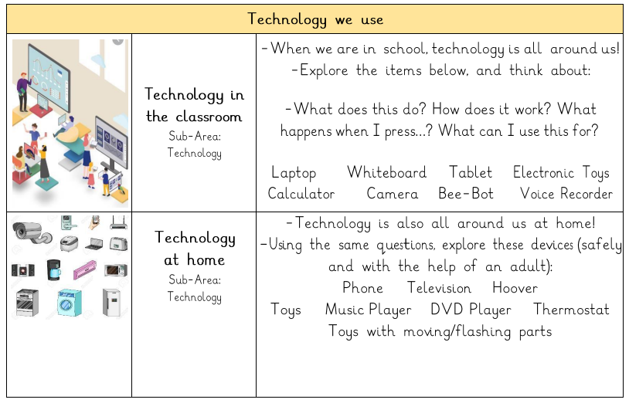
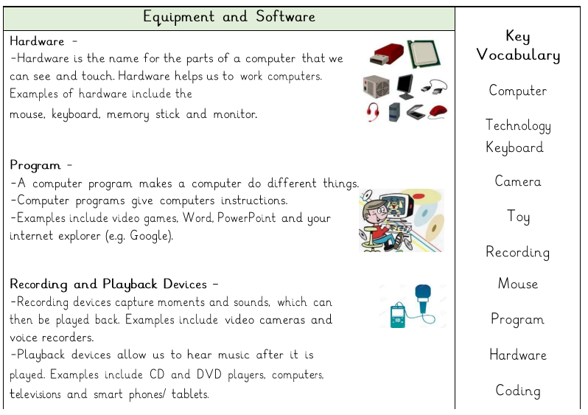
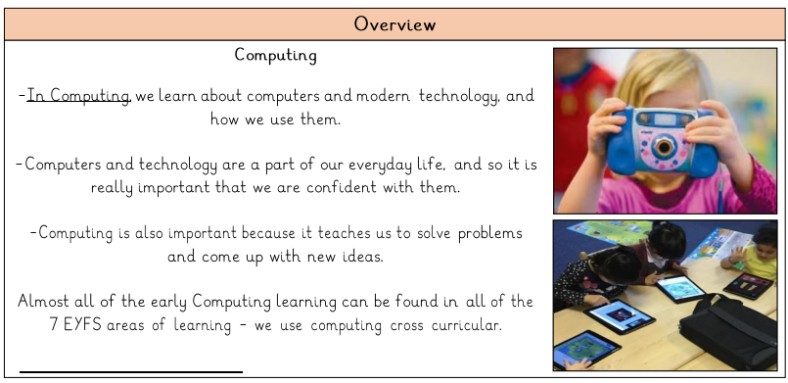
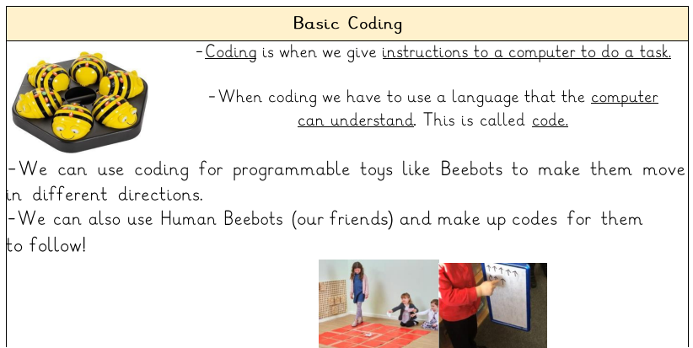
Our computing journey through the year
Health and Safety

