Characteristics of Effective Learning: Playing and exploring – children investigate and experience things and have a go; Active learning – children concentrate and keep trying if they encounter difficulties and enjoy achievements; Creating and thinking critically – children have and develop their own ideas, make links between ideas, and develop strategies for doing things. In addition, the prime area of learning PSE, CL and PD underpin and are an integral part of all areas of learning.
Expressive Arts & Design Educational Programme: The development of children’s artistic and cultural awareness supports their imagination and creativity. It is important that children have regular opportunities to
engage with the arts, enabling them to explore and play with a wide range of media and materials. The quality and variety of what children see, hear and participate in is crucial for developing
their understanding, self-expression, vocabulary and ability to communicate through the arts. The frequency, repetition and depth of their experiences are fundamental to their progress in
interpreting and appreciating what they hear, respond to and observe.
Intent: Through our Music Curriculum at Kimbolton school we want to stir children’s creativity through playing, performing, listening and experimenting with music. We value music as a form
of expression and build a joy and a love of music through a well-planned curriculum. We realise potential and develop pride and teamwork through regular performances.
Charanga | Me! | My Stories | Everyone |  | Our World | Big Bear Funk | Reflect, rewind, replay
Learning Overview | We will move in time to music and tap out a simple rhythm. We will perform our favourite nursery rhymes. We will learn and perform songs for the Christmas Show. We will follow Charanga plans for music. |  | We will move in time to music and tap out a simple rhythm. We will perform a selection of traditional nursery rhymes. We will also follow Charanga plans for music. |  |  | We will perform a selection of traditional nursery rhymes/songs from other countries. We will also follow Charanga plans for music.
Term | Autumn 1 | Autumn 2 | Spring 1 |  | Spring 2 | Summer 1 | Summer 2
Music  Evidence on Tapestry  We revisit knowledge and skills throughout the year | To find the pulse in different ways and show this through actions eg clapping, moving like a character from the song.  To copy back the rhythm of their name.  To copy sounds they can hear to distinguish high-pitched sounds from low-pitched sounds.  To learn to sing the song in unison with support.  To add actions or substitute a word in some sections.  To choose one of the songs and perform it with any actions you have created. | To recognise and name some of the characters and stories in the songs.  To find the pulse in different ways and show this through actions eg marching, jumping, moving like a character from the song  To copy back a rhythm from the words of the song.  To copy phrases from the songs to discuss high-pitched sounds from low-pitched sounds.  To play a pitched note or sound in time with the pulse.  To learn to sing the song in unison with support.  To add actions or substitute a word in some sections.  To choose one of the songs and perform it with any actions you have created. | To find the pulse in different ways and show this through actions eg marching, jumping, moving.  To copy back the rhythms of phrases in the song  To copy sounds they can hear to distinguish high-pitched sounds from low-pitched sounds.  To play a 1-note pattern in time with the pulse.  To learn to sing or rap the songs in unison with support.  To add actions or substitute a word in some sections.  To choose one of the songs or the rap and perform it with any actions you have created  To listen back to the performance. |  |  | To find the pulse in different ways and show this through actions eg funky monkey, funky chicken or funky bear.  To copy back the rhythm of words from the video.  To clap the rhythm of words from the song.  To play the pulse with a pitched note or untuned percussion instrument.  To add one pitched sound to the rhythm of words and short phrases from the song.  To learn to sing the songs in unison with support.  To add actions or substitute a word in some sections.  To choose one of the songs and perform it with any actions you have created.  To listen back to the performance
Music Sticky Knowledge  Knowledge children need to know by the end of every half-term. | I know some nursery rhymes. | I know how to clap the pulse (beat)  I know familiar worship songs | I know that instruments make different sounds.  I know that pitch is how high or low a sound is.  I know that performance is sharing music with others. |  |  | I know there are different types of music around the world.  I know 5 nursery rhymes by heart.  I know how to play some percussion instruments correctly.  I know the names of some percussion instruments.
Key vocabulary | pulse, rhythm, pitch, high sounds, low sounds, perform, unison, phrase, boogie |  | pulse, rhythm, pitch, high sounds, low sounds, tempo, perform, rap, unison, congo, rondo, concerto, phrase |  |  | pulse, rhythm, pitch, high sounds, low sounds, tempo, perform, rap, unison, funk
Main Songs | Pat-a-cake  1, 2, 3, 4, 5, Once I Caught a Fish Alive  This Old Man  Five Little Ducks  Name Song  Things For Fingers | I’m A Little Teapot  The Grand Old Duke Of York  Ring O’ Roses  Hickory Dickory Dock  Not Too Difficult  The ABC Song | Wind The Bobbin Up  Rock-a-bye Baby  Five Little Monkeys Jumping On The Bed  Twinkle Twinkle  If You're Happy And You Know It  Head, Shoulders, Knees And Toes | Old Macdonald  Incy Wincy Spider Baa Baa Black Sheep  Row, Row, Row Your Boat  The Wheels On The Bus  The Hokey Cokey |  | Big Bear Funk  Baa Baa Black Sheep  Twinkle Twinkle  Incy Wincy Spider  Rock-a-bye Baby  Row, Row, Row Your Boat
Our Curriculum Goal | To become a Proud Performer who can perform a song, poem or dance to an audience, retell stories with expression and confidence, play a range of percussion instruments correctly and with good rhythm.
ELG  (End of the year only) | Being Imaginative and Expressive  - Invent, adapt and recount narratives and stories with peers and their teacher;  - Sing a range of well-known nursery rhymes and songs;  - Perform songs, rhymes, poems and stories with others, and – when appropriate try to move in time with music.
During KS1, children will learn | During KS1, children will learn  - Use their voices expressively and creatively by singing songs and speaking chants and rhymes  - Play tuned and untuned instruments musically  - Listen with concentration and understanding to a range of high-quality live and recorded music  - Experiment with, create, select and combine sounds using the inter-related dimensions of music.

Our musical journey through the year

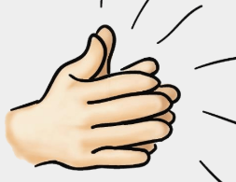
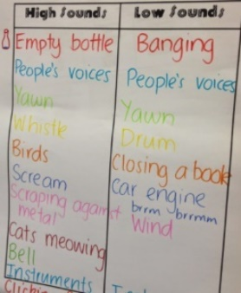
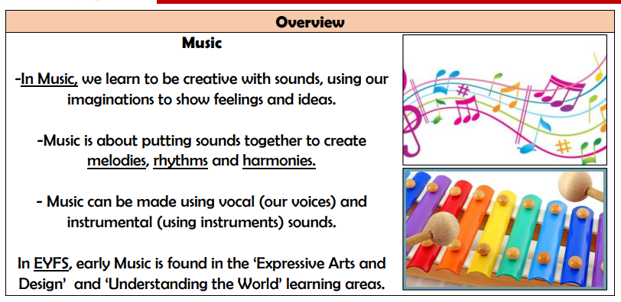
To copy sounds they can hear to distinguish high-pitched sounds from low-pitched sounds.
To add one pitched sound to the rhythm of words and short phrases from the song.

To show the pulse through clapping
To copy back the rhythm of their name

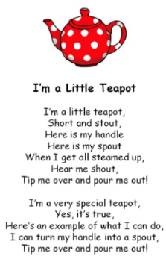

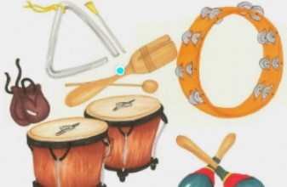
To add actions or substitute a word in some sections.

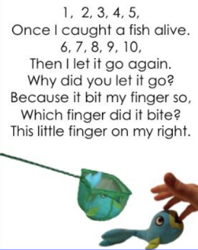
To choose one of the songs or the rap and perform it with any actions you have created

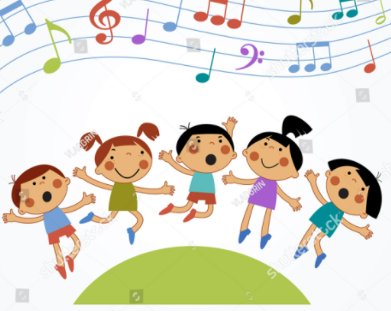
To play the pulse with a pitched note or untuned percussion instrument.

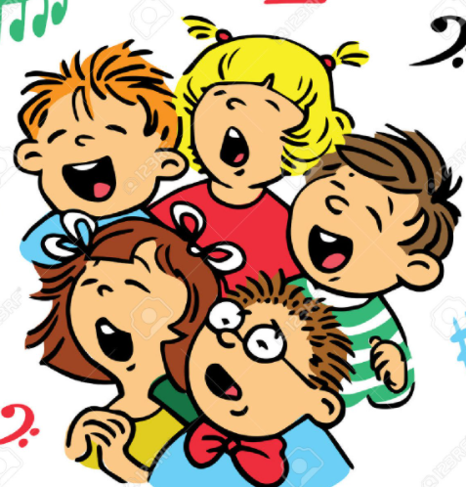

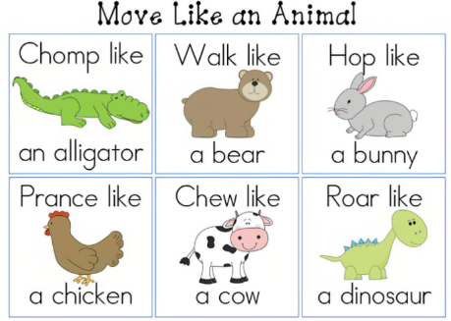

To learn to sing the song in unison with support

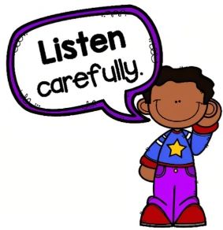

To listen back to the performance

To find the pulse in different ways and show this through actions eg moving like a character from the song.

To find the pulse in different ways and show this through actions eg marching, jumping,

