Characteristics of Effective Learning: Playing and exploring – children investigate and experience things and have a go; Active learning – children concentrate and keep trying if they encounter difficulties and enjoy achievements; Creating and thinking critically – children have and develop their own ideas, make links between ideas, and develop strategies for doing things. In addition, the prime area of learning PSE, CL and PD underpin and are an integral part of all areas of learning.
Understanding the World Educational Programme: Understanding the world involves guiding children to make sense of their physical world and their community. The frequency and range of
children’s personal experiences increases their knowledge and sense of the world around them – from visiting parks, libraries and museums to meeting important members of society, such as
police officers, nurses and firefighters. In addition, listening to a broad selection of stories, non-fiction, rhymes and poems will foster their understanding of our culturally, socially,
technologically and ecologically diverse world. As well as building important knowledge, this extends their familiarity with words that support understanding across domains. Enriching and
widening children’s vocabulary will support later reading comprehension.
Intent: Through the Geography curriculum at Kimbolton we equip children with the skills and language of geographical enquiry. We believe our children deserve first-hand
experiences to make geography come alive. During their journey at Kimbolton, the children will learn about their locality, the United Kingdom and the wider world. Our children leave reception with an increased knowledge and sense of the physical world around them, their community and the wider world. They will respect the world around them and others, celebrating our similarities and differences. The children will have a greater sense of themselves and the changing environment. Through their learning the children will experience using a range of equipment and sources (including maps) to enable them to find out and gather information which they then use to further their understanding and learning. They will have opportunities to explore, observe and find out about places, cultures and environment, and will partake in visits to local areas and school trips that will enhance their learning.
Themes | A1 - I wonder what’s marvellous about me  A2 - I wonder what we celebrate |  | Sp1 – I wonder what’s above and beyond the clouds  Sp2 – I wonder what’s out there |  | S1 – I wonder where this journey will take us  S2 - I wonder what happened in the past
Learning Overview | We will learn about where we live, and we will try to remember our street name and house number. Using a map, we will be able to find the UK and know that England, where we live, is a part of the UK and Kimbolton as the school we go to. We will describe our environment and draw a simple map. We will learn about religious cultures within our school and community. We will celebrate Harvest, Diwali and Christmas, and understand why some people do this every year. We will be able to recall the Christmas story and perform this during our Christmas Nativity show. |  | We will compare living in the countryside to the town. We will learn about religious cultures within our school and community. We look at local farmers and discuss how important they are for our society and community. We will celebrate Chinese New Year and Easter and understand why some people do this every year. We will be able to recall the Easter story and visit St James Church. |  | We will be able to locate our country on a world map and locate another country. We will talk about some similarities and differences between our country and others. We will be able to say hello in another language. We will explore where dinosaurs lived when they were alive e.g. land, skies and sea. We will learn about religious cultures within our school and community.
Term | Autumn 1 | Autumn 2 | Spring 1 | Spring 2 | Summer 1 |  | Summer 2
Geography  Evidence in Floor Book  We revisit knowledge and skills throughout the year | To be able to draw information from a simple map for their local area and understand a map gives you directions.  To identify buildings and roads from aerial maps.  To know Kimbolton as the village the school is located in. | To be able to talk about members of their immediate family and community.  To know, name and describe people who are familiar to them.  To know and understand that some places are special to members of their community.  To comment on experiences of a wide range of experiences and celebrations | To be able to talk about the lives of people around them and their roles in society.  To talk about different religions and celebrations  To talk about life in China compared to the UK. | To recognise some environments that are different from the one in which they live.  To build an imaginary setting using construction. | To be able to recognise some similarities and differences between life in this country and life in other countries – home focus.  To create a journey of an imaginary setting and use some features.  To make a journey stick and then create own map with key features. |  | To understand that dinosaurs lived in skies, land and sea.  To know that some things in the world are man-made, and some things are natural.
Geography Sticky Knowledge  Knowledge children need to know by the end of every half-term. | I know I live in England/UK  I know about the features of my own immediate environment  I know the name of the village the school is located in.  I know how to use and draw information from a simple map | I know some of the people who work in my community and what they do. | I know some of the festivals that are celebrated around the world. | I know about similarities and differences between places e.g. countryside and town  I know that different foods are grown around the world.  I know the name of some animals in the UK. | I know some similarities and differences between life in this country and life in another country. | I know that some things in the world are man-made, and some things are natural.
Key vocabulary | map, aerial, birds-eye view, local, UK, England, Kimbolton, village, Leominster, town, street, house, building, road | community, place, celebration, church, India | society, world, China, UK | countryside, town, buildings, farming, environment | map, globe, imaginary, feature, country, hot, cold, warm, hot, sun, snow, ice, weather | sky, land, sea, manmade, natural
Our Curriculum Goals | To become an Exceptional Explorer who can show curiosity about the world around them, understand how to read and draw a simple map, understand some differences between times and places.  To become a Compassionate Citizen who can help to look after their community and care for the environment, know some reasons why Kimbolton is special, have an awareness of other people’s cultures and beliefs.
ELG  (End of the year only) | - Describe their immediate environment using knowledge from observation, discussion, stories, non-fiction texts and maps.  - Know some similarities and differences between different religious and cultural communities in this country, drawing on their experiences and what has been read in class.  - Explain some similarities and differences between life in this country and life in other countries, drawing on knowledge from stories, non-fiction texts and – when appropriate – maps.
During KS1, children will learn | During KS1, children will learn  Locational knowledge  - Name and locate the world’s seven continents and five oceans  - Name, locate and identify characteristics of the four countries and capital cities of the United Kingdom and its surrounding seas  Place knowledge  - Understand geographical similarities and differences through studying the human and physical geography of a small area of the United Kingdom, and of a small area in a contrasting non-European country  Human and physical geography  - identify seasonal and daily weather patterns in the United Kingdom and the location of hot and cold areas of the world in relation to the Equator and the North and South Poles  - Use basic geographical vocabulary to refer to:  - Key physical features, including beach, cliff, coast, forest, hill, mountain, sea, ocean, river, soil, valley, vegetation, season and weather  - Key human features, including city, town, village, factory, farm, house, office, port, harbour and shop  Geographical skills and fieldwork  - Use world maps, atlases and globes to identify the United Kingdom and its countries, as well as the countries, continents and oceans studied at this key stage  - Use simple compass directions (North, South, East and West) and locational and directional language [for example, near and far; left and right], to describe the location of features and routes on a map  - Use aerial photographs and plan perspectives to recognise landmarks and basic human and physical features; devise a simple map; and use and construct basic symbols in a key  - Use simple fieldwork and observational skills to study the geography of their school and its grounds and the key human and physical features of its surrounding environment.  SEASONAL CHANGES  - Observe changes across the four seasons.  - Observe and describe weather associated with the seasons and how day length varies.

EYFS geography knowledge and skills linking to year 1
Locational Knowledge  I know I live in England/UK  I know about the features of my own immediate environment  I know the name of the village and city the school is located in. | Geographical Skills and Fieldwork  Begin to use geographical skills, including first-hand observation, to enhance their locational awareness |  |  | Place Knowledge  Identify similarities and differences between places, drawing on my experiences and what has been read in class  Explain some similarities and differences between life in this country and life in other countries, drawing on knowledge from stories, non-fiction texts and – when appropriate – maps. | Manmade and Natural Geography  Model the vocabulary needed to name specific features of the natural world, both natural and manmade  Understand the effect of changing seasons on the natural world around me
 | Collect, analyse and communicate a range of data gathered through experiences of fieldwork. | Interpret a range of sources of geographical information, including maps, diagrams, globes, photographs and geographical information systems, such as, Google Earth. | Communicate geographical information in a variety of ways e.g. maps and drawings.
I know how to use and draw information from a simple map
I can look at aerial views and comment on buildings, open space, roads and other simple features

Our geography journey through the year
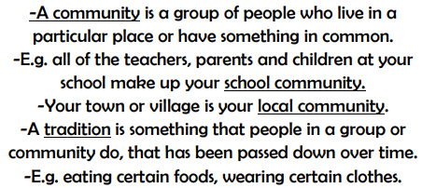
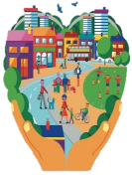
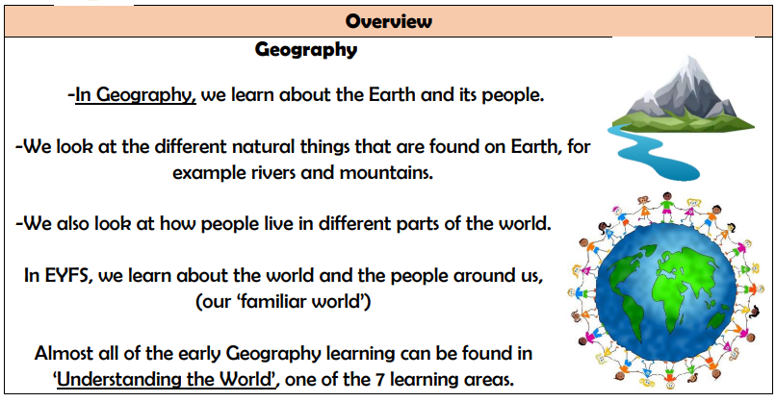
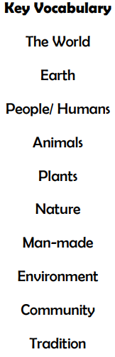
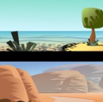
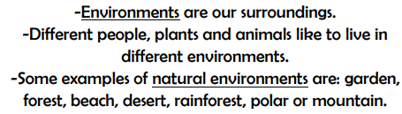
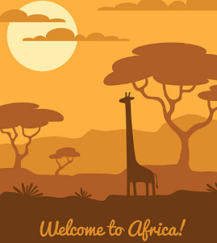
To talk about the lives of people around them and their roles in society.

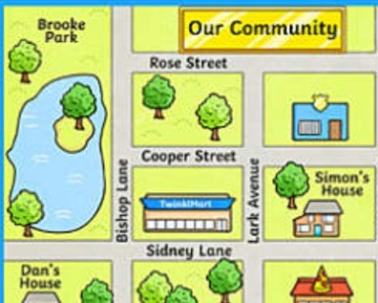
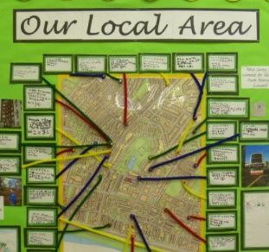
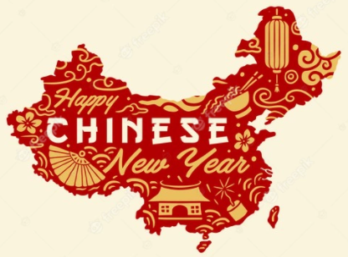

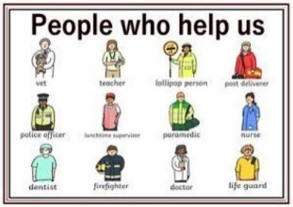
To recognise similarities and differences to UK and a contrasting country.

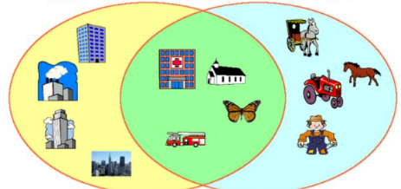
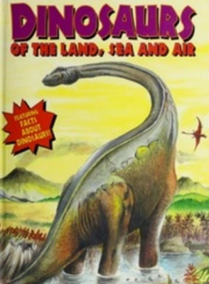
To draw information from a simple map for their local area and understand a map gives you directions
To identify buildings and roads from aerial maps.
To draw a map of an imaginary setting and understand some features.
To create their own maps and include some simple features.

To talk about different religions and celebrations and understand China is bigger than the UK.
To comment on experiences of a wide range of experiences and celebrations

To know that St James is a special place to members of their community.
To know Kimbolton is a village the school is located in.

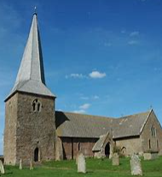
To recognise some environments that are different from the one in which they live.
The countryside is surrounded by mostly fields and is open and town is surrounded by buildings and closed up. They may share churches, hospitals and other important building.

To understand dinosaurs lived in the skies, land and seas.

